|  |  |
| --- | --- |
|  | **How to apply to enroll in B A 353** |

# **Apply to enroll in B A 353 by submitting a +New Experience form**

* Log into [RecruitMcCombs](https://mccombs-utexas.12twenty.com/Login).
* Select the B A 353/653 module of RecruitMcCombs, highlighted below.

* Click the “+ New Experience” button in the upper right-hand corner. Enter your internship details. Once all fields are completed, click “Save” in the top or bottom-right corner.

**IMPORTANT! Be sure to select your Employer name from the drop down.** Start by searching for the name slowly. Only if the employer is not listed should you create “+ Add New Employer”

* After saving your internship details, navigate to "Documents and Forms" to upload any additional documents you wish to add.
* Once your internship details are saved and any documents uploaded, click “Submit for Approval” in the top-right corner of the B A 353/653 module.

* Your form’s status will change to “*Pending Initial Approval,*” and the system will send you a confirmation email notifying you that your submission was received.

**IMPORTANT!**

* DO NOT complete the Supervisor Acknowledgement form.
* DO NOT share the survey with your supervisor.

Wait until the end of your internship to complete these steps. Instructions will be provided on Canvas.

* The B A 353 faculty will review your application.
  + If the faculty approve your application, you will receive two emails, one notifying you that your application has been approved, and another explaining your next steps. Once approved, your form’s status will change to “*In Progress*.”

* + If your application requires changes before it can be approved, you will receive an email identifying the information that needs to be added or changed.
    - Your form’s status will change to “*Needs More Information (Initial)*”
    - The reason for your form being in this status will appear at the top of your application.
    - Edit your application as required, and click Submit for Approval.

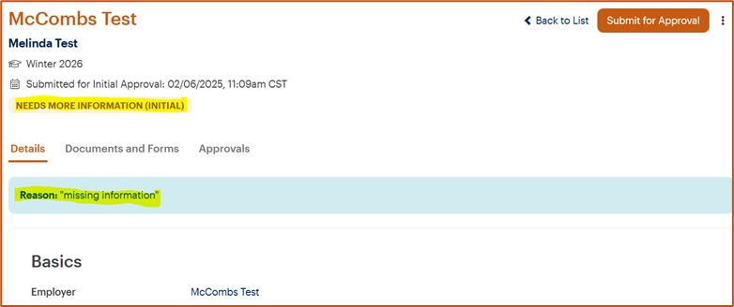

**IMPORTANT!**

* DO NOT complete the Supervisor Acknowledgement form.
* DO NOT share the survey with your supervisor.
* DO NOT submit your application for final approval.

Wait until the end of your internship to complete these steps. Instructions will be provided on Canvas.